# John Lopes

December 15, 2024

# CS 255 System Design Document

## UML Diagrams

### UML Use Case Diagram

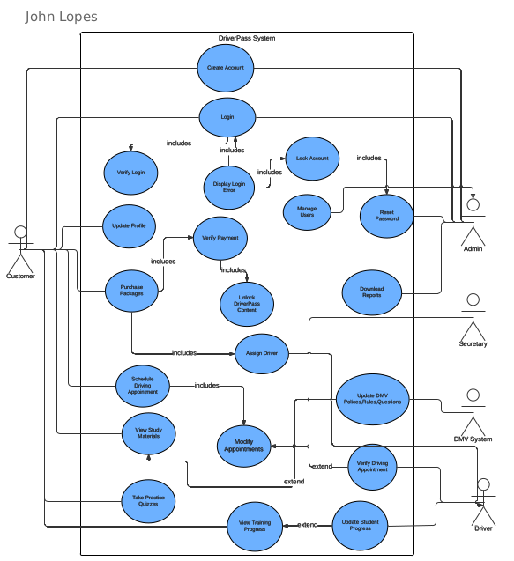

### UML Activity Diagrams

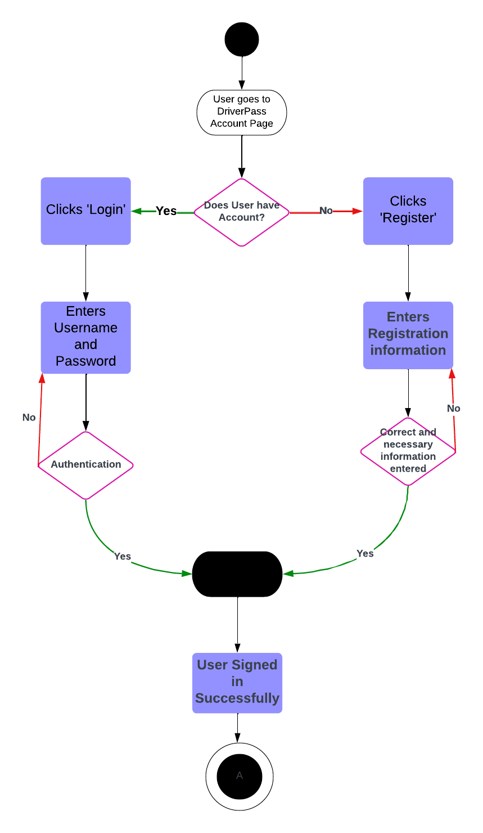

### UML Sequence Diagram

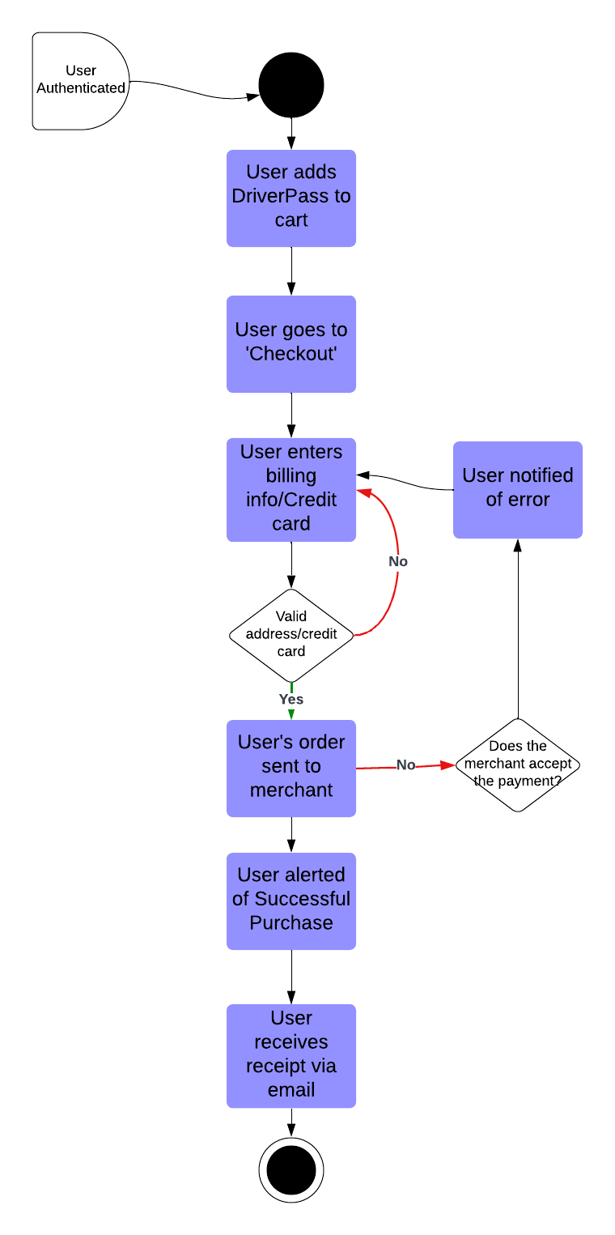

### UML Class Diagram

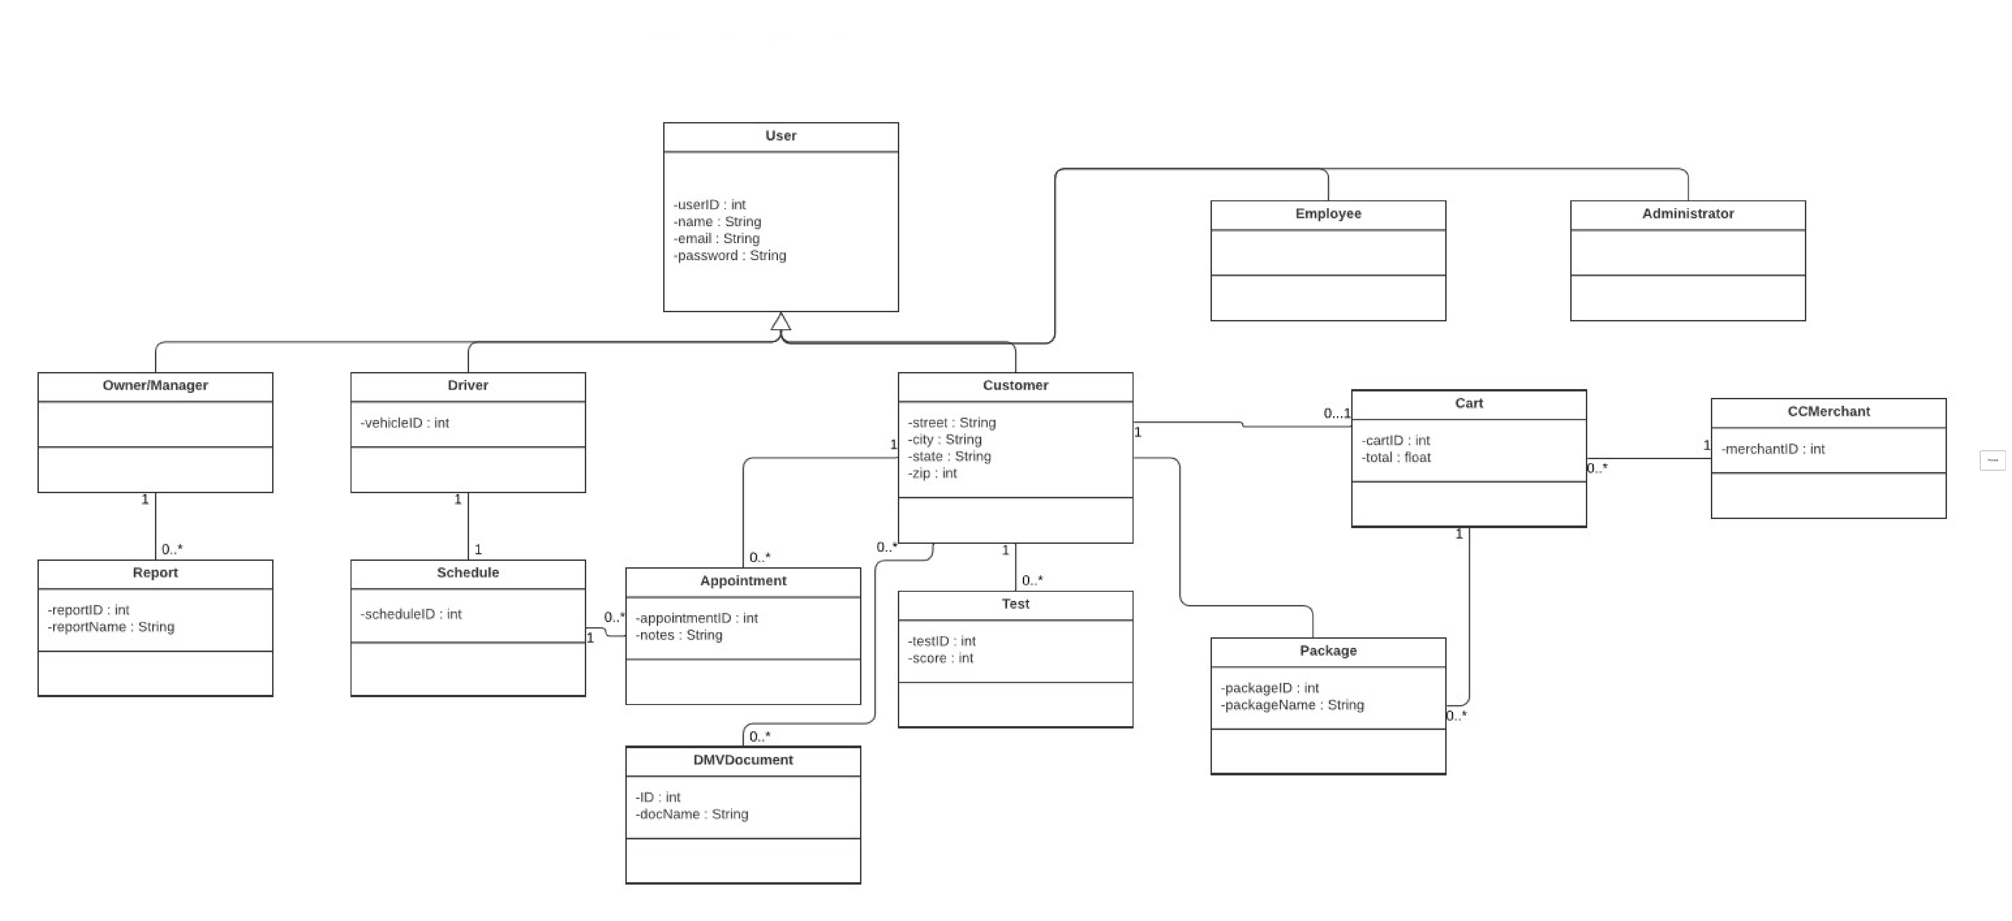

## Technical Requirements

The system design for the DriverPass application requires a great infrastructure that includes specific hardware, software, and geographic considerations to ensure optimal functionality, accessibility, and security. To support the DriverPass application, a dedicated server is necessary to host the system and manage traffic effectively. The server must include sufficient storage capacity to maintain the database and website data, ensuring fast retrieval and smooth operations. A reliable internet connection is essential to enable seamless user access and uninterrupted functionality. Users can interact with the website using a computer or mobile device. Additionally, a firewall will be deployed to protect the system's ports, mitigating the risk of unauthorized access and securing the website from external threats.

The system's software infrastructure will leverage a stable version of Windows Server for hosting, as it is a reliable and compatible option. A SQL Server is recommended for database management, providing robust capabilities for handling and querying data. Backup software will be implemented to create regular backups of the website and database, ensuring business continuity in case of system failures. An Apache web server will handle HTTP requests and deliver website content efficiently. To safeguard the system from malicious attacks, comprehensive security software will be employed to detect and prevent malware.

To meet accessibility requirements, the website will be designed to ensure smooth operation across the United States. The server hosting the website and database will be secured in a reputable data center, providing physical security and stable environmental conditions. To optimize performance and reduce latency, the server will be located in a central geographic region, ensuring efficient access for users across the country.